**Review of 2016 Supermarket Subset Sales**

Lindsay Pritikin

Regis University

MSDS 670: Data Visualization

Professor John Koenig

March 6, 2022

The Superstore Subset dataset consists of sales data for seventeen product sub-categories across 2013-2016. These sub-categories range from Furniture, Technology, and Office Supplies products. All sub-categories sell across Consumer, Corporate, and Home Office segments. There are four salespeople, one per region in the US: West, East, Central, and South. The purpose of this analysis is to analyze the most recent year, 2016, against historical performance. It is also of interest to use any key takeaways from this analysis as recommendations for 2017 goals and focuses.

From 2013-2014 there was a dip in sales, however since then overall sales have been on an upward trend increasing +29% in 2015 and +21% in 2016. All regions hit record high sales figures in 2016, with the exception of the Central region which was flat year-over-year. Anna Andreani hit a company record-high in 2016 of over $250K. She was the top salesperson of the year, performing 37% above average sales. 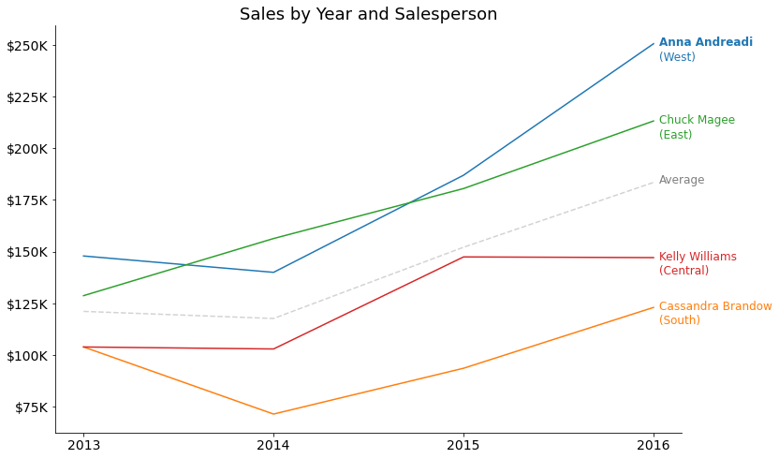

2016 was a successful year for the Superstore, with sales up across all segments compared to the year prior. In total sales were up +$125K from 2015, totaling to $734K for the year. The Consumer segment drove the strongest sales in 2016 at $332K, accounting for 45% of sales for the year overall. While the Consumer segment drove the largest volume of sales, it showed the lowest improvement year-over-year compared to other segments at a +12% increase. Nonetheless, the net change year-over-year for the Consumer segment is significantly positive. On the other hand, the Home Office segment had the lowest volume of sales at $183K, but showed the greatest improvement year-over-year at +52%. The Corporate segment fell in the middle, driving $207K in 2016 sales with a +17% improvement year-over-year.

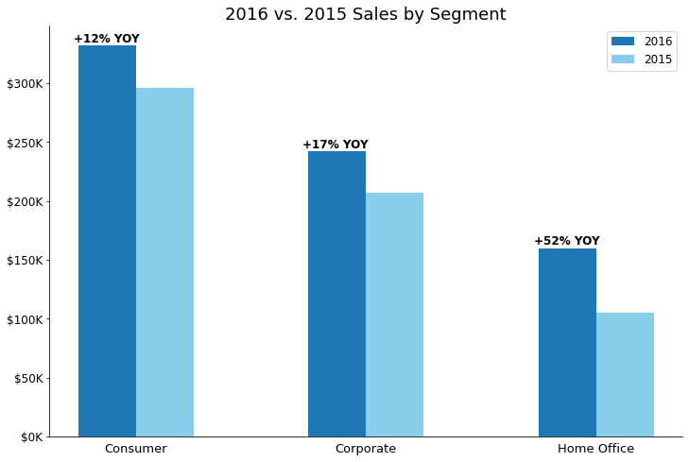

Net profit margins were positive in 2016 at $94K overall across all sub-categories. However, four out of the seventeen product sub-categories had negative margins and should be reviewed: tables, machines, supplies, and bookcases. Tables had the worst margin by far in 2016 at -$8.1K, followed by machines at -$2.9K, supplies at -$1K, and bookcases at -$0.6K. It is worth reviewing these products’ prices as well as discussing potential options with wholesalers. On the other hand, other product sub-categories had stellar profit margins, specifically copiers at a $25K profit in 2016. Accessories, phones, and paper also had strong profit margins at $15.7K, $12.9K, and $12K respectively.

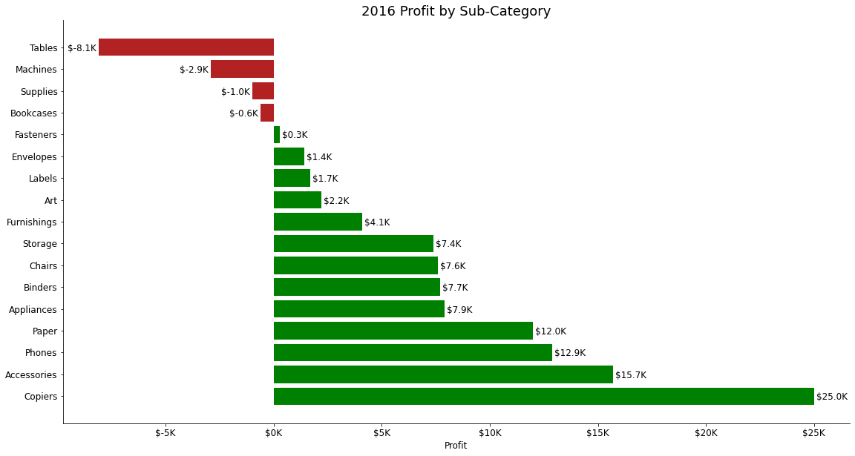

Lastly, when reviewing product seasonality by quarter in 2016, it is evident that seasonality varies by product. However, overall Q4 is the strongest quarter. Certain sub-categories have more extreme seasonality than others. For instance, tables have 57% of sales coming in during Q4. Phones have higher sales in the second half of the year, posting double the sales compared to the first half of 2016. Common back-to-school items such as binders, art, supplies, and accessories have the strongest sales in Q3 when students go back to school. Using this seasonality as guidance, it is recommended to develop marketing and promotional windows at optimal times for products. This will allow the Superstore to further capitalize on success when products are in highest demand. The Superstore can also use seasonality to inform inventory needs that will align with supply and demand, and help reduce any potential sellouts.

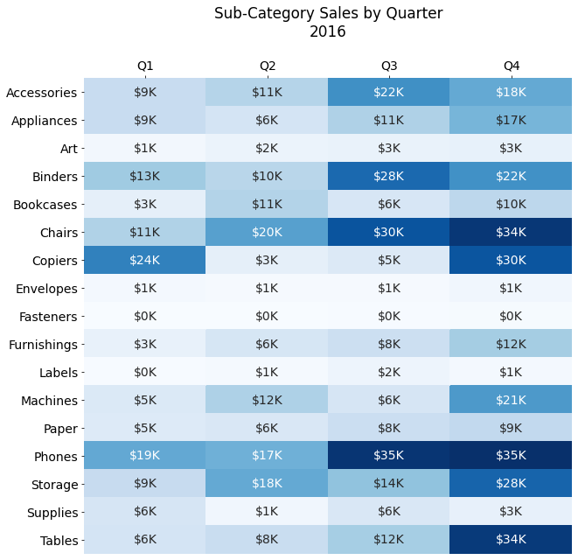

In conclusion, the Superstore Subset data shows that 2016 was the most successful year to date, driving $734K in sales, up +$125K from the year prior. Overall sales have been increasing over the past two years, up +21% in 2016 and +29% in 2015. These sales have increased across all segment categories: Consumer, Corporate, and Home Office. Net profit is positive at $94K overall, however four sub-categories had negative profit margins. Tables, machines, supplies, and bookcase prices should be reviewed and potential options should be discussed with wholesalers. Another recommendation is focused on marketing, and using seasonality windows as guidance for promotional efforts and inventory needs. While Q4 is the strongest overall, it is clear that seasonality varies by product sub-category.